First United Methodist Church
At the Corner of State Road 128 and 8th Street
Pastor Bob Preusz
109 South 8th Street | 765-754-7996
P.O. Box 338 | Web: www.franktonfirstumc.org
Frankton, IN 46044 | E-mail: franktonfirstumc@gmail.com
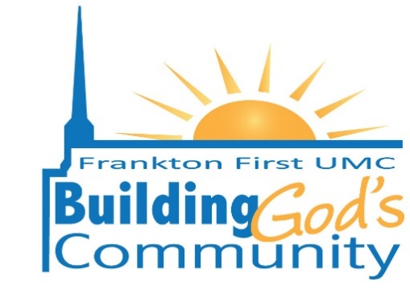

Thank you for considering the First United Methodist Church and its facilities for your upcoming event.

The First United Methodist Church is committed to Building God’s Community and we welcome any activity which furthers that goal.

As you might imagine, activities sponsored by the First United Methodist Church shall have priority unless prior approval for the date requested has been given.

The attached application details rental fees, rules and procedures for using our facilities for your event. Please read the agreement thoroughly. You are not allowed to use stoves, ovens, fryers, warming ovens, refrigerators, etc. in the kitchen at The Factory or church. We also cannot accommodate multiple crock pots plugged into the same circuit.

You are allowed to use the serving area and the clean-up area of the kitchen. If you desire a full meal, our caterer, the Faithful Servers, is the caterer we require you to use (unless another caterer is approved by the Trustees). Their prices are reasonable and the food is great. They are able to work with you on creating a specific menu for your event.

In addition to the rules set forth in the application, we have posted Building Use Rules and Rules of Conduct that you and your participants, by your signing an accepted application, agree to follow.

Applications for use of our church’s facilities shall be submitted at the church office at least ten (10) days prior to the date of the proposed event along the deposit. Approval or denial of your application shall be provided within four (4) business days of the receipt of your application.

Countless hours of hard work have been expended by our church members in order to prepare and maintain our facilities for your use. In the event your application is accepted, we thank you, in advance, for your courtesy in taking good care of them and for any donation you might want to make for use of the facility.

Please contact the church office at (765) 754-7996 with any questions you might have. Our office hours are Monday and Thursday from 8:30-12:30 and Tuesday 12:3- 2:30.

God bless,

Bob Preusz

Bob Preusz, Pastor

